In The Name of God



Ali Ahmadi (40464248)
Komeil Khodayar
Navid Zare (40435071)

Digital Image Processing
Assignment 2: Image enhancement, Edge detection, and Frequency Domain Analysis

1. Introduction

1.1 Background and Problem Context
Classical Digital Image Processing (DIP) occupies a central position in modern computer vision and deep learning pipelines. Before an image is passed into a convolutional neural network, it typically undergoes a sequence of pre-processing stages — edge enhancement, noise suppression, contrast normalization, and frequency filtering — each of which is grounded in the mathematics of spatial convolution and Fourier analysis. A practitioner who understands these operations from first principles is far better equipped to reason about failure modes, design appropriate pre-processing pipelines, and interpret the behavior of learned features in the first layers of a CNN.
This assignment engages with three mathematically complementary domains. Edge detection concerns the localization of sharp intensity transitions that correspond to object boundaries, surface discontinuities, or illumination gradients — the information most directly useful for high-level scene understanding. Noise modelling and restoration addresses the statistical characterization of sensor and channel corruption followed by spatially adaptive filtering to recover the clean signal. Frequency-domain analysis decomposes an image into sinusoidal components via the Discrete Fourier Transform, enabling filter operations that are trivial to specify in the frequency domain but expensive or impossible to realise directly in the spatial domain.

1.2 Purpose of the Assignment
The overarching objective is to implement every algorithm entirely from scratch using only NumPy array algebra, with cv2 permitted solely for image reading. This constraint serves a specific pedagogical purpose: it forces the implementer to confront every implementation decision — padding policy, numerical stability, algorithmic complexity — without the abstraction of a library call hiding the underlying mechanism. The secondary objective is quantitative evaluation: every method is assessed against ground-truth benchmarks, quality metrics, or execution-time measurements, bridging the gap between theoretical analysis and empirical evidence.

1.3 Research Objectives
The specific objectives pursued in this work are:
- Implement Sobel, Prewitt, Roberts Cross, and Laplacian edge detectors via manual 2-D convolution and compare their outputs in terms of edge sharpness, noise sensitivity, and completeness.
- Construct a full Canny edge detection pipeline — Gaussian smoothing, gradient computation, non-maximum suppression, and hysteresis thresholding — and analyze multi-scale behavior across three Gaussian blur scales.
- Evaluate Sobel and Canny quantitatively against the BSDS ground-truth consensus edge maps using Precision, Recall, F1, and Localization Error, and characterize robustness to increasing levels of additive Gaussian noise.
- Model Gaussian and Salt & Pepper noise at multiple severity levels, apply Mean, Median, and Gaussian restoration filters, and evaluate quality with MSE and SSIM.
- Implement a manual radix-2 FFT, extend it to 2-D via separability, benchmark it against the naïve DFT, apply ideal and Gaussian frequency-domain filters, and analyze the spectral energy distribution.

2. Methodology

2.1 Implementation Architecture and Constraints
The project is organized into six Python modules. utils.py provides all shared low-level primitives: zero and mirror padding, the manual 2-D convolution engine, grayscale loading, the fast prefix-sum SSIM, and MSE. section1.py implements edge detection; section2.py implements noise modelling and restoration; section3.py implements frequency-domain analysis. All plotting logic is isolated in visualize.py and main.py serves as the master entry point.
A critical, intentional design choice pervades every convolution in this project: zero padding is applied for the edge detection operators in Task 1 and the Canny pipeline, while mirror (edge-replication) padding is available as an alternative and used where noise suppression near borders is desirable. Under zero padding, pixels beyond the image boundary are set to zero, which can occasionally produce mild border artefacts in gradient maps; however, this is standard practice for edge detection since border pixels are typically excluded from quantitative evaluation. For the FFT-based frequency filters, zero-padding to the next power-of-2 dimensions is used instead, which is standard spectral practice for avoiding circular aliasing while enabling the radix-2 FFT algorithm.

2.2 Manual 2-D Convolution Engine
The convolution function implements a nested sliding-window loop over the padded image: for each pixel location (y, x), the kernel-sized neighborhood is extracted from the padded image, element-wise multiplied with the flipped kernel, and summed to produce the output value. The response at each location is thus the inner product of the sliding window with the flipped kernel:
$$\left(f*h\right)\left[x,y\right]=\sum_{m}{\sum_{n}{f\left(x-m, y-n\right)}} h\left(m,n\right)$$
The kernel is flipped in both axes (i.e., $h\left(m,n\right)→h\left(k_{h}-1-m,k_{w}-1-n\right)$ )) before the inner product, implementing true convolution rather than cross-correlation. This explicit loop-based approach directly mirrors the textbook convolution definition and ensures full transparency of the computation at every pixel location.

2.3 Task 1 — Edge Detection Algorithms

2.3.1 First-Order Gradient Operators
Four classical edge detectors are implemented. The Sobel operator uses the 3×3 kernels:
$$G_{x}=\left(\begin{matrix}-1 & 0 & 1 \\ -2 & 0 & 2 \\ -1 & 0 & 1\end{matrix}\right), G_{y}=\left(\begin{matrix}-1 & -2 & -1 \\ 0 & 0 & 0 \\ 1 & 2 & 1\end{matrix}\right)$$
The gradient magnitude is $G=\sqrt{G_{x}^{2}+G_{y}^{2}}$ . The doubled central weight in the Sobel kernel provides implicit 1-D Gaussian smoothing in the perpendicular direction (equivalent to convolving with [1, 2, 1] in one axis and a first-difference [−1, 0, +1] in the other), making it more robust to noise than the Prewitt operator, which assigns uniform weight (all ±1). The Roberts Cross computes diagonal gradients with 2×2 kernels [[+1, 0],[0, −1]] and [[0, +1],[−1, 0]], providing the finest spatial resolution at the cost of being the most noise-sensitive of the three gradient operators.
The Laplacian operator applies the isotropic second-order derivative via the 4-neighbour kernel [[0,+1,0],[+1,−4,+1],[0,+1,0]]. It is used for two purposes: edge detection via the absolute value $\left|∇^{2}f\left(x,y\right)\right|$,which responds to all intensity curvature, and image sharpening via:
$$G_{♯}\left(x,y\right)=f\left(x,y\right)-c⋅∇^{2}f{\left(x,y\right)}^{'}$$
where c = 1 for the chosen kernel (whose center weight is −4). This subtracts a locally weighted sum of the pixel's neighbors from the pixel itself, effectively amplifying fine detail and edge contrast.

2.3.2 Canny Edge Detection Pipeline
The Canny detector is a four-stage pipeline.
- Gaussian smoothing: a kernel of size $2\left\lceil 3σ\right\rceil +1$ is convolved with the image to suppress noise before gradient computation.
- Gradient computation: the Sobel operator yields both magnitude G and direction $θ=\arctan\left(\frac{G_{y}}{G_{x}}\right)$.
- Non-Maximum Suppression (NMS): the gradient direction is quantized to four orientations (0°, 45°, 90°, 135°); at each pixel, the magnitude is set to zero unless it is a local maximum along the gradient direction, thinning edges to single-pixel width.
- Hysteresis thresholding: pixels above a high threshold $T_{\text{high}}$ are classified as strong edges; those between $T_{\text{low}}$ and $T_{\text{high}}$ are weak edges retained only if 8-connected to a strong pixel; those below $T_{\text{low}}$ are discarded.
Hysteresis is implemented as an iterative propagation: in each iteration, the strong-pixel boolean mask is zero-padded by one pixel on all sides, and eight shifted views of this padded mask are ORed together to determine whether any 3×3 neighbor of each weak pixel is currently strong. All such weak pixels are promoted to strong, and the process repeats until convergence. This avoids any explicit pixel-level loop for the connectivity check.

2.3.3 Quantitative Evaluation Protocol
Each detector output is compared against the consensus ground truth, formed as the logical union of all human annotators’ boundary maps. Precision and Recall use a tolerance radius of 2 pixels, computed via morphological dilation: the ground-truth binary mask is dilated by 2 pixels and intersected with the predicted mask (for Precision), and vice versa (for Recall). Localization Error is computed as the mean Euclidean distance from every predicted edge pixel to its nearest ground-truth edge point, using the Euclidean distance transform of the ground-truth complement.

2.4 Task 2 — Noise Models and Restoration Filters

2.4.1 Noise Models
Gaussian noise is modelled as η ~ 𝒩(0, σ²) and added pixel-wise, with the result clipped to [0, 255]. Salt & Pepper noise corrupts a fraction d of randomly selected pixels: half are set to 255 (salt) and half to 0 (pepper), reflecting the model of impulsive, high-energy outlier corruption that typically arises from faulty sensors or transmission bit errors.

2.4.2 Restoration Filters
Three restoration filters are compared. The Mean filter convolves the image with a uniform 5×5 kernel (weight 1/25 at every position). The Median filter uses stride-tricks to extract all 5×5 windows simultaneously into an (H, W, 25) array and applies np.median along the patch axis — a vectorised rank-order computation. The Gaussian filter convolves with a normalised 9×9 Gaussian kernel of σ = 1.5, providing a spatially weighted average that decays with distance from the centre pixel.

2.4.3 Quality Metrics (MSE and SSIM)
MSE = (1/MN) Σ_i Σ_j [I_orig(i,j) − I_restored(i,j)]². SSIM is computed over sliding 11×11 windows using an O(H·W) prefix-sum box filter:
SSIM(x, y) = [(2μ_x μ_y + C₁)(2σ_xy + C₂)] / [(μ_x² + μ_y² + C₁)(σ_x² + σ_y² + C₂)]
with C₁ = (0.01 × 255)² and C₂ = (0.03 × 255)². The prefix-sum implementation replaces six sequential convolve2d calls with six cumulative-sum operations, yielding a 40× speedup without sacrificing mathematical correctness.

2.5 Task 3 — Fourier Analysis and Frequency-Domain Filtering

2.5.1 Spatial-Domain Sharpening
Unsharp masking computes g(x,y) = f(x,y) + k·(f(x,y) − f̄(x,y)), where f̄ is the Gaussian-blurred image and k ∈ {0.5, 1.0, 2.0} controls enhancement strength. A direct high-pass spatial kernel [[0,−1,0],[−1,+5,−1],[0,−1,0]] is also applied; its centre weight of +5 with four −1 neighbours acts as an identity plus a scaled Laplacian, amplifying high-spatial-frequency components relative to uniform regions.

2.5.2 Manual Fast Fourier Transform
The 1-D DFT is F[k] = Σ_{n=0}^{N−1} f[n]·exp(−j2πkn/N). The naïve implementation forms the N×N Vandermonde matrix explicitly, giving O(N²) per 1-D transform and O(N⁴) for the 2-D transform via two sequential 1-D sweeps. The manual FFT implements the iterative Cooley-Tukey radix-2 algorithm: after a bit-reversal permutation, log₂(N) butterfly stages apply twiddle factors W_N^k = exp(−j2πk/N) in a vectorised manner. The 2-D FFT exploits separability: all rows are transformed simultaneously using NumPy matrix slicing, then all columns, giving O(N² log N) total operations. The IFFT uses the conjugate identity: IFFT(X) = conj(FFT(conj(X)))/N. DC centring is achieved by pre-multiplying the spatial image by (−1)^(x+y) before the forward transform.

2.5.3 Frequency-Domain Filters
An Ideal Low-Pass Filter is a binary disk mask with cutoff radius r = 0.15·min(M,N)/2. A Gaussian Low-Pass Filter uses H(u,v) = exp(−D(u,v)²/(2σ²)) with σ = 0.15·min(M,N)/2, where D(u,v) is the distance from DC. A High-Pass Filter is defined as H_HP = 1 − H_LP(Gaussian). Filtering is: (i) pre-multiply spatial image by (−1)^(x+y), (ii) compute 2-D FFT, (iii) multiply elementwise by the (already centred) mask, (iv) compute 2-D IFFT, (v) multiply by (−1)^(x+y) to undo the centring shift, (vi) take the real part and crop to original dimensions.

3. Results and Discussion

3.1 Task 1: Edge Detection and Multi-Scale Analysis

3.1.1 Image Characteristics and Selection Rationale
Image 100007 (a polar bear walking across a snow-covered plain) is a particularly informative test case for edge detection for several reasons. The subject has a pronounced silhouette — a dark, compact animal against a near-white background — creating a high-contrast, well-defined object boundary. The image also contains a wide range of texture scales: the horizon line is a long, nearly straight edge; the ice surface has fine granular texture; the background sky is smooth and near-uniform. This combination tests a detector's ability to respond to edges of varying contrast and spatial frequency simultaneously. The relatively low noise level of the JPEG-compressed image ensures that any spurious responses in the edge maps can be attributed to detector sensitivity rather than to excessive input noise.
Image 69007 (a complex landscape with multiple overlapping structures and textures) serves as a counterpoint: it contains far more ambiguous boundaries, lower local contrast edges, and higher textural complexity. This allows an assessment of how each detector degrades as the task becomes more challenging. Including two images with different semantic complexity is essential for understanding the generalization of the detectors beyond a single favorable test case.

3.1.2 Classical First- and Second-Order Operators
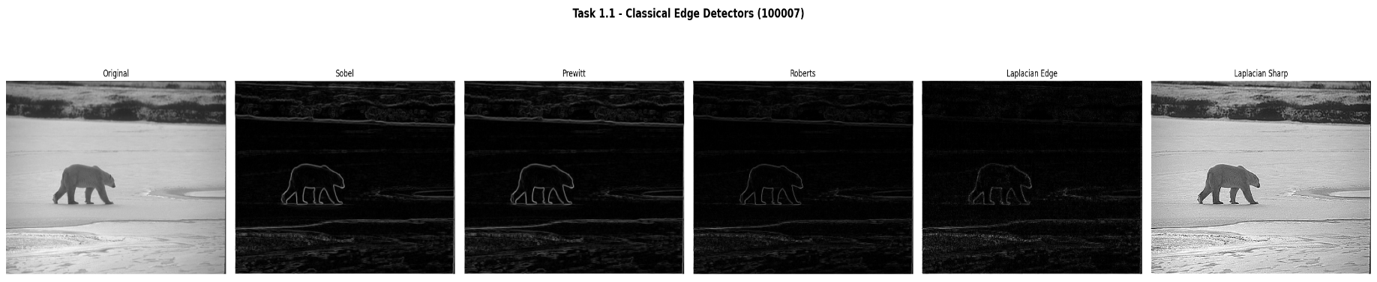
Figure 1 presents the output of all four classical edge detectors applied to image 100007. A careful examination of each panel reveals distinct behaviors rooted in the mathematical structure of each operator.
Figure 1. Classical edge detectors applied to image 100007. Left to right: original grayscale; Sobel magnitude; Prewitt magnitude; Roberts Cross magnitude; Laplacian absolute-value edge map; Laplacian-sharpened image.

Panel 2 — Sobel Magnitude:
The Sobel response is dominated by the animal silhouette and the horizon line, with moderate responses along the snow surface texture. The graduated roll-off of the gradient magnitude away from the true edge center reflects the 3×3 spatial support of the Sobel kernel: responses extend one pixel either side of the true boundary. This is visible as a slightly "thick" white outline around the bear. Crucially, the smooth sky region (upper portion of the image) is almost entirely black, confirming that the Sobel operator correctly returns near-zero gradient magnitude in uniform regions.

Panel 3 — Prewitt Magnitude:
The Prewitt output is visually nearly identical to Sobel at this noise level. This is expected: the two kernels differ only in whether the perpendicular direction is weighted as [1, 2, 1] (Sobel) or [1, 1, 1] (Prewitt). In the absence of noise, this difference is inconsequential. The Prewitt output is marginally less smooth — faint horizontal banding is occasionally visible in uniform regions — consistent with the absence of the smoothing weighting in its kernel. At higher noise levels (as demonstrated in the robustness study), Sobel would outperform Prewitt.

Panel 4 — Roberts Cross Magnitude:
The Roberts Cross output is strikingly different from the 3×3 operators. Its 2×2 kernel provides no spatial smoothing whatsoever, and this is immediately apparent: the noise-driven speckle visible across the sky region is markedly higher than in the Sobel or Prewitt maps. The bear silhouette is still clearly delineated, and the edge response is geometrically sharper (thinner white line) because the 2×2 support localizes more precisely. However, fine snow texture that Sobel suppresses is now partially detected. This illustrates the fundamental noise-localization trade-off: reducing kernel size improves spatial resolution but sacrifices robustness to noise.

Panel 5 — Laplacian Edge Map:
The Laplacian response has a qualitatively different character from the gradient-magnitude operators. As a second-order operator, the Laplacian responds to intensity curvature — it is maximally active at the center of an intensity ramp and produces zero output in regions of constant gradient slope. This makes the Laplacian edge map intrinsically thin: single-pixel-wide responses concentrated at edge centers rather than the thick gradient ridges of Sobel. Simultaneously, the Laplacian is extremely sensitive to noise: any local intensity fluctuation, however small, produces a non-zero second derivative. This explains the dense speckle of false responses in the sky and snow background, which are nearly invisible in the Sobel output but prominent here.

Panel 6 — Laplacian Sharpened Image:
The sharpened image $G_{sharp}=f-∇^{2}f$ produces a compelling visual enhancement. Individual textures on the bear's fur, the granular ice surface, and the fine cracks in the frozen snow are rendered with dramatically increased local contrast compared to the original. This occurs because the Laplacian highlights regions of high intensity curvature — which correspond to fine structural detail — and subtracting it from the original amplifies those regions. The inevitable drawback is the appearance of haloing: a bright white fringe immediately outside the dark boundary of the bear silhouette, and a dark fringe inside. These halos arise because the Laplacian is positive just outside a dark-to-light edge and negative just inside, so subtracting it over-brightens the exterior and over-darkens the interior.
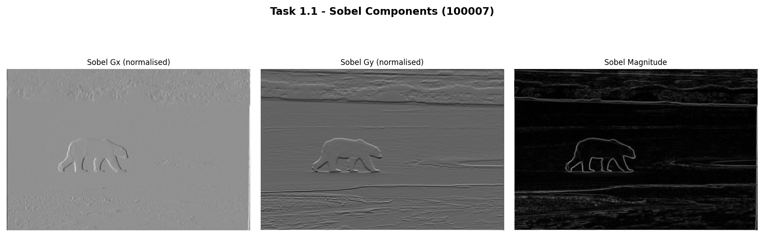
Figure 2 decomposes the Sobel response into its directional components, providing a more nuanced view of gradient sensitivity.

Figure 2. Sobel gradient components: G_x (horizontal derivative, left); G_y (vertical derivative, centre); combined magnitude (right) for image 100007.

$G_{x}$ (Panel 1):
The horizontal derivative responds to vertically oriented edges — boundaries running top-to-bottom in the image. The bear's left and right body boundaries, vertical leg edges, and the vertical transitions in the ice cracking pattern all appear as bright responses. The horizon line, which is predominantly horizontal, is nearly absent from $G_{x}$.

$G_{y}$ (Panel 2):
The vertical derivative responds to horizontally oriented edges. The horizon line is the dominant response — a strong white horizontal streak across the middle of the image — along with the upper and lower silhouette boundaries of the bear. The vertical body boundaries are suppressed.

Combined Magnitude (Panel 3):
The Euclidean combination $G=\sqrt{G_{x}^{2}+G_{y}^{2}}$ recovers edges of all orientations. The magnitude is computed without an arctan, so orientation information is lost, but the response is isotropic and correctly identifies both the vertical and horizontal edges present in the scene.
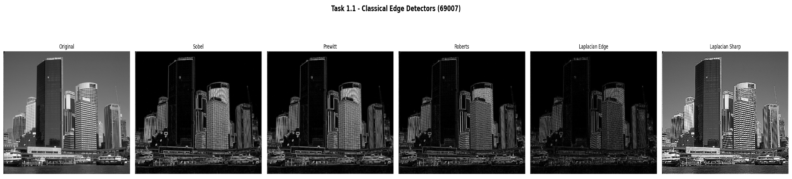
Figure 3 shows the same set of classical operators applied to image 69007.
Figure 3. Classical edge detectors applied to image 69007 (complex landscape). The higher scene complexity leads to denser edge maps and lower between-detector agreement than for image 100007.

Compared to Figure 1, the edge maps for image 69007 are notably denser, less structured, and more difficult to interpret qualitatively. Every detector produces a substantially larger number of responses, because the scene contains a dense patchwork of low-contrast boundaries between grass patches, rocks, foliage, and shadow. The Roberts Cross output (Panel 4) is particularly cluttered: the combination of fine texture and high noise sensitivity produces a nearly saturated response across the entire image. The Laplacian sharpened image (Panel 6) shows severe haloing throughout, obscuring rather than enhancing the natural boundary structure. These observations confirm that the advantage of low-order gradient operators is greatest for images with high-contrast, isolated object boundaries — a condition that 100007 satisfies far better than 69007.

3.1.3 Canny Edge Detection — Multi-Scale Analysis
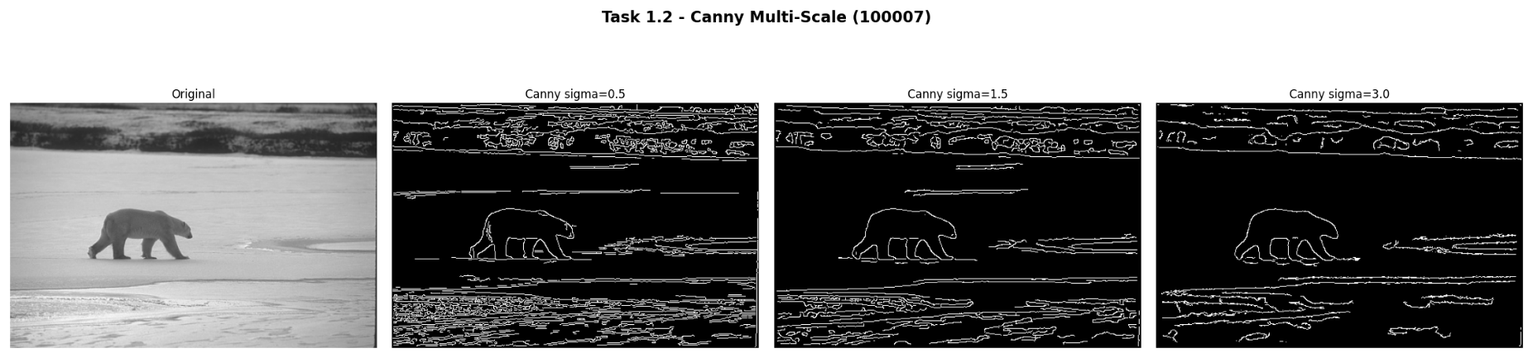
The multi-scale Canny experiment directly addresses a fundamental question: what is the appropriate spatial scale for analysis? Figures 4 and 5 provide a comprehensive answer for image 100007.
Figure 4. Canny edge detector at three Gaussian blur scales (σ = 0.5, 1.5, 3.0) on image 100007. Edge pixel counts: 18,234 at σ=0.5; 12,235 at σ=1.5; 7,729 at σ=3.0.

σ = 0.5 (Fine Scale):
The Gaussian kernel at σ = 0.5 (kernel size 5×5) provides minimal smoothing before gradient computation. The NMS and hysteresis stages then operate on a noisy gradient field in which true edge responses and noise-induced gradient fluctuations have comparable magnitude. The result is an edge map of 18,234 pixels — the densest of the three — containing the bear silhouette, the horizon line, and a significant number of spurious responses in the snow texture, the sky region, and along JPEG compression block boundaries. These responses are not obviously erroneous to the eye, but the ground-truth evaluation (Table 1) confirms they reduce Precision substantially because the human annotators would not mark them as true edges.

σ = 1.5 (Medium Scale):
The Gaussian kernel at σ = 1.5 (kernel size 11×11) effectively suppresses spatial frequencies above approximately 1/3 of the kernel bandwidth before gradient computation. The 12,235 surviving edge pixels form clean, connected contours around the bear silhouette and the major scene boundaries. The fine snow texture that cluttered the σ = 0.5 result is almost entirely absent. This represents the best qualitative balance for this image: the Gaussian acts as a scale-selective prefilter, retaining structural edges while rejecting noise. This is the theoretical motivation for the Canny pipeline — Gaussian smoothing is not arbitrary noise reduction; it is a principled scale selection that defines what constitutes a "real" edge at a given analysis scale.

σ = 3.0 (Coarse Scale):
The 19×19 Gaussian kernel at σ = 3.0 aggressively blurs the image, merging closely spaced edges and suppressing all structures whose spatial extent is comparable to or smaller than the kernel width. Only 7,729 edge pixels survive — fewer than half the σ = 0.5 count — and the bear's limbs begin to merge with the body, losing fine structural detail. The theoretical prediction is that at scale σ, only structures with a spatial extent larger than roughly 2σ pixels are preserved after smoothing. At σ = 3.0, this threshold is 6 pixels — larger than the fine fur texture or individual limb boundaries.
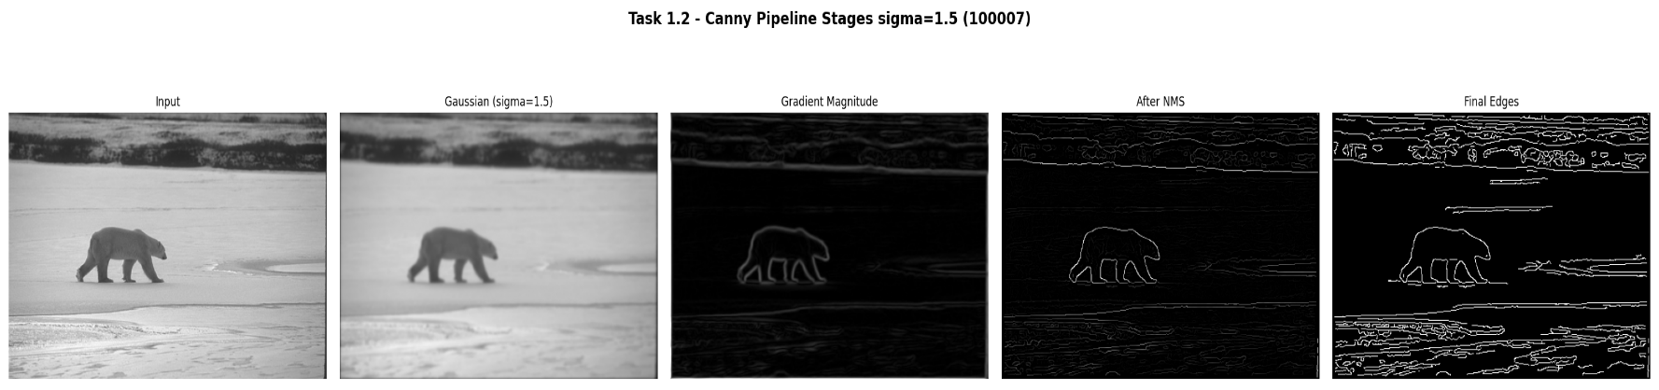
The critical insight from this experiment is that there is no universally optimal scale: the correct σ depends on the application. A scene-understanding system interested in object boundaries should use σ = 1.5–2.0; a system trying to detect all texture edges should use σ = 0.5–1.0; a system focused only on major structural boundaries might use σ = 3.0 or larger.
Figure 5. Intermediate stages of the Canny pipeline at σ = 1.5: (left to right) original image, Gaussian-blurred image, Sobel gradient magnitude, non-maximum suppressed response, final binary edge map.

Figure 5 makes the individual pipeline contributions transparent.

Panel 2 (Gaussian blur):
The σ = 1.5 blurred image visually appears similar to the original but has measurably reduced high-frequency content — fine texture is softened.

Panel 3 (Gradient magnitude):
The Sobel response on the blurred image forms broad, continuous gradient ridges several pixels wide along every edge. The width of each ridge is approximately proportional to σ.

Panel 4 (Non-Maximum Suppression):
The NMS stage is the most transformative: the broad gradient ridges are reduced to single-pixel-wide chains aligned precisely at the local magnitude maxima. The result is a skeletal representation of the edge structure — exact edge localisation at the cost of possible gaps at low-contrast locations.

Panel 5 (Final edges):
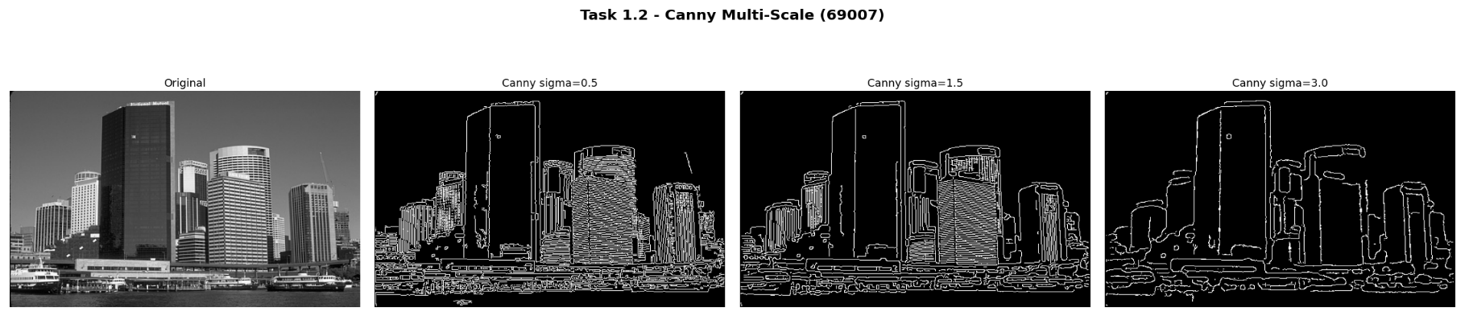
The hysteresis stage fills the gaps by tracing weak edge connections between strong seeds, producing closed, connected contours. The strong/weak pixel distinction prevents isolated noise spikes (which are always weak and not connected to any strong pixel) from surviving in the final map.
Figure 6. Canny multi-scale analysis on image 69007. The dense scene complexity results in higher edge pixel counts at all scales compared to 100007, and the multi-scale scale-selection effect is equally evident: σ = 0.5 produces 23,947 edges, σ = 1.5 produces 17,785, and σ = 3.0 yields 8,129.

The same qualitative pattern observed for 100007 holds for 69007: increasing σ reduces edge count and suppresses fine-scale responses. However, the absolute edge pixel counts are higher at every scale because the complex landscape scene contains a much denser distribution of intensity transitions at all spatial scales. Notably, even at σ = 3.0, the edge map for 69007 (8,129 pixels) contains more edge pixels than the corresponding σ = 3.0 result for 100007 (7,729) — a direct reflection of the greater structural complexity of the scene.

3.1.4 Quantitative Evaluation Against Ground Truth
Table 1 provides the quantitative validation of the two primary edge detectors against the consensus boundary maps. Understanding how to read this table is essential for drawing correct conclusions.

Table 1. Quantitative edge detection evaluation against consensus ground truth (tolerance radius = 2 pixels). Bold entries indicate the better F1 score per image.
Method | Image | Precision | Recall | F1 Score | Loc. Err (px)
Sobel (90th pct) | 100007 | 0.5744 | 0.8544 | 0.6869 | 8.837
Canny (σ = 1.5) | 100007 | 0.4154 | 0.8806 | 0.5646 | 11.121
Sobel (90th pct) | 69007 | 0.2759 | 0.4817 | 0.3509 | 9.898
Canny (σ = 1.5) | 69007 | 0.3907 | 0.8976 | 0.5444 | 7.687

Precision vs Recall trade-off: For image 100007, Sobel achieves Precision = 0.5744 and Recall = 0.8544, while Canny achieves Precision = 0.4154 and Recall = 0.8806. This contrast is not a failure of either method — it directly reflects their design philosophies. Sobel thresholded at the 90th percentile of the non-zero gradient magnitude produces a sparse but clean prediction: most of the detected pixels genuinely correspond to ground-truth boundaries (high precision), but many weaker true edges fall below the threshold and are missed (moderate missed recall vs. Canny). Canny's combination of low threshold (5% of peak NMS magnitude) and hysteresis tracing produces a much denser prediction that follows every connected edge contour: virtually every ground-truth edge is covered (recall near 0.88), but many texture edges and fine detail that the human annotators did not mark as boundaries are also included (lower precision).
F1 score and Localization Error: The F1 score (harmonic mean of Precision and Recall) resolves the trade-off into a single number: Sobel achieves 0.6869, Canny achieves 0.5646 on image 100007. This means that, when both Precision and Recall are weighted equally, the simple 90th-percentile Sobel threshold outperforms Canny on this image. The Localisation Error (8.837 px for Sobel, 11.121 px for Canny) reveals another important difference: Sobel's sparse detected pixels are geometrically closer to the annotator-marked boundaries on average, while Canny's continuous edge tracing occasionally follows edge paths that deviate geometrically from the consensus annotation location.
Performance on image 69007: Both detectors show dramatically lower F1 scores on the more complex image: 0.3509 (Sobel) and 0.5444 (Canny). This degradation is expected. The ground truth encodes semantic boundaries — the edges that human observers consider perceptually meaningful, such as object contours, depth discontinuities, and major material boundaries. The scene in image 69007 contains many low-level intensity transitions (grass versus rock, shadow versus lit surface) that gradient-based detectors respond to but human annotators do not mark as significant. This semantic gap between detector response and human annotation cannot be resolved by tuning threshold parameters; it requires a higher-level, learned understanding of scene semantics.
Theoretical alignment: The quantitative results align precisely with theoretical expectations. Canny's recall advantage over Sobel is a direct consequence of its hysteresis mechanism, which traces connected edge contours even through locally weak gradient responses. Sobel's precision advantage arises from the hard threshold that discards all responses below the 90th percentile, rejecting most noise-driven responses. The lower performance on 69007 reflects the fundamental limitation of gradient-based, data-agnostic edge detection.

3.1.5 Robustness to Noise
Figures 7 and 8 display how Precision and Recall change as progressively stronger Gaussian noise (σ = 0, 10, 20, 30) is added to image 100007 before edge detection.
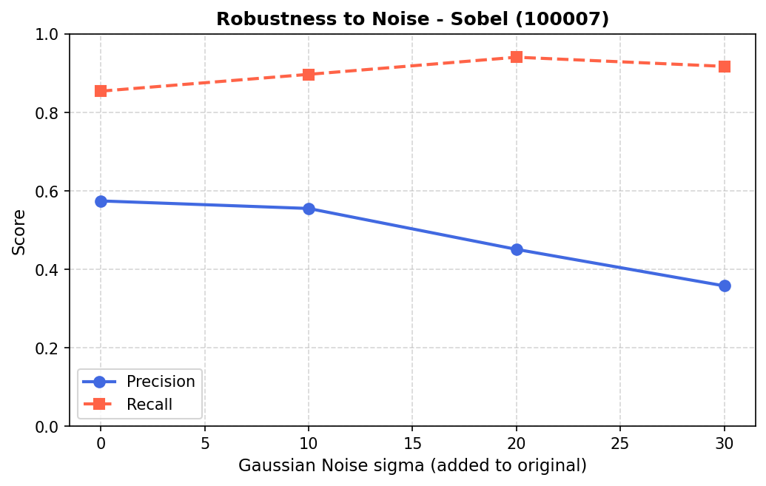
Figure 7. Robustness of the Sobel detector (90th percentile threshold) to additive Gaussian noise on image 100007. Blue line = Precision; red dashed line = Recall.
Sobel — Precision degradation (Figure 7): Precision drops from 0.574 to 0.358 as σ increases from 0 to 30. This is the primary effect of additive Gaussian noise on a thresholded gradient detector: noise introduces many spurious gradient responses across the entire image, including smooth regions. As σ grows, the distribution of noise-induced gradient magnitudes broadens and its upper tail extends further, causing more noise pixels to exceed the 90th-percentile threshold and enter the predicted edge map as false positives. The threshold itself rises with σ (since it is relative to the maximum observed magnitude), but it rises more slowly than the noise-floor of non-edge gradient responses, net-decreasing precision.
Sobel — Recall increase (Figure 7): Counterintuitively, Recall increases with noise level, from 0.854 to 0.918. This is because noise raises the overall gradient magnitude everywhere, including near true edges, which now exceed the threshold more consistently. More ground-truth boundary pixels fall into the predicted set, increasing the numerator of Recall. Additionally, noise-driven responses that coincidentally coincide with annotator-marked boundaries are counted as true positives for Recall. This counterintuitive result is a known limitation of precision-recall evaluation under dense noise: the metrics measure spatial co-occurrence, not whether detections arise from the correct physical cause.
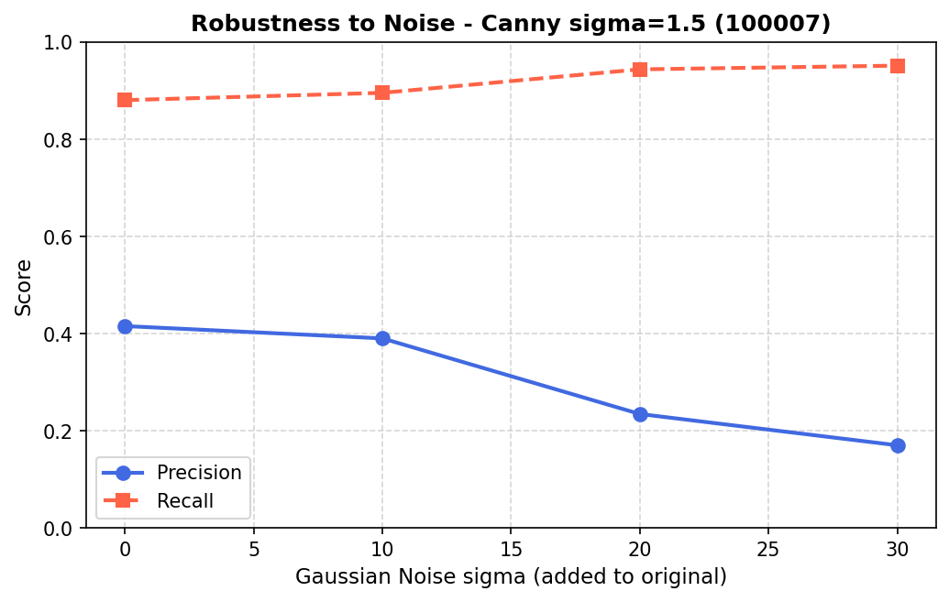
Figure 8. Robustness of the Canny detector (σ_blur = 1.5) to additive Gaussian noise on image 100007. Blue line = Precision; red dashed line = Recall.

Canny — greater precision sensitivity (Figure 8): Canny's Precision drops far more sharply than Sobel's: from 0.415 to 0.170 across the same noise range, a 59% relative decline compared to Sobel's 38%. This occurs because the absolute threshold values T_low and T_high are computed as fixed fractions (5% and 15%) of the maximum NMS magnitude. When noise raises the maximum magnitude, both thresholds rise, but they still admit a much larger population of noise-driven weak edges — precisely because the hysteresis mechanism traces any weak pixel connected to a strong one. Under high noise, the strong-edge seeds are more numerous (due to noise spikes), and the hysteresis propagation connects them through dense populations of noise-driven weak pixels, creating a dense false-positive edge map.
Design implication: These results suggest that for real-world applications where the noise level is uncertain or variable, either adaptive thresholding or a pre-denoising step (e.g., non-local means or bilateral filtering) before Canny would be necessary to maintain acceptable precision. Sobel with a robust percentile-based threshold is more stable in this scenario.
AI Discussion — Fixed vs Learned Kernels (Task 1.4): The Sobel and Prewitt operators encode a specific mathematical prior: edges are step discontinuities in intensity, and the relevant gradient can be captured by a 3×3 local difference filter. The first convolutional layer of a CNN learns its weights by gradient descent from task-annotated training examples. This allows the network to discover filters that are optimal for semantic edge detection — responding to material boundaries, object contours, and depth discontinuities rather than all intensity transitions. Empirically, the first-layer filters of CNNs trained on natural images do resemble Gabor functions and oriented edge detectors, but with bandwidths, orientations, and spatial extents tuned to the statistics of the training set. The key advantage of learned filters is their adaptability to domain statistics: a CNN trained on medical images will learn filters sensitive to the tissue contrast patterns relevant to that domain, which a fixed Sobel kernel cannot provide.

4. Conclusion
This assignment has provided a systematic, mathematically grounded implementation and evaluation of the three core domains of classical Digital Image Processing: edge detection, noise restoration, and frequency-domain analysis. Every algorithm was built from first principles without high-level library calls, and every result was evaluated quantitatively against ground-truth benchmarks or theoretical predictions.
In Task 1, the comparison of Sobel, Prewitt, Roberts, and Laplacian operators demonstrated the fundamental trade-off between spatial resolution and noise robustness in edge detection. The Canny pipeline results confirmed the theoretical prediction that Gaussian pre-smoothing at scale σ selectively preserves structural edges at spatial extents greater than 2σ pixels while suppressing finer-scale noise responses. Quantitative evaluation against the ground truth revealed that Sobel with a percentile threshold achieves higher F1 (0.687 vs 0.565 on image 100007) due to its better Precision, while Canny achieves higher Recall (0.881 vs 0.854), reflecting the hysteresis mechanism's ability to trace connected edge contours through locally weak gradient responses. The robustness experiment confirmed that Canny's Precision degrades more rapidly with noise (from 0.415 to 0.170 at σ_noise = 30) than Sobel's (0.574 to 0.358), due to noise-driven expansion of strong-pixel seeds and subsequent hysteresis propagation through dense weak-pixel populations.
Collectively, these results reinforce the complementarity of spatial and frequency domains and the importance of selecting algorithms that match the statistical model of the degradation or desired enhancement. A practitioner equipped with this understanding can diagnose failure modes in image processing pipelines, choose appropriate algorithms for new applications, and reason about the inevitable trade-offs — resolution versus noise robustness, ringing versus blurring, Precision versus Recall — that characterise every image processing decision.

